

**WAREHOUSE MANAGEMENT APPLICATION**

**Software Requirement Specification (SRS) Document**

**Sprint Implementation**

**Project Timeline: 20.10.2022 to 27.10.2022**

**INDEX**

|  |  |  |
| --- | --- | --- |
| 1 | Introduction | 3 |
|  | 1.1 Purpose | 3 |
|  | 1.2 Intended audience | 3 |
|  | 1.3 Intended view | 3 |
|  | 1.4 Scope | 3 |
|  | 1.5 Definition | 4 |
| 2 | Overall description | 4 |
|  | 2.1 Assumptions and dependency | 4 |
| 3 | System feature and requirement | 6 |
|  | 3.1 Functionality | 6 |
|  | 3.2 System requirement | 6 |
|  | 3.2.1 Tools to be used | 6 |
|  | 3.3 System feature | 6 |
| 4 | Data Flow Diagram | 7 |
|  | 4.1 DFD Level 0 | 7 |
|  | 4.2 DFD Level 1 | 8 |

**1. INTRODUCTION:**

The introduction of the software requirement specification provides an overview of the entire software. The entire SRS with overview description purpose, scope, tools used and basic description.

The aim of this document is to gather, analyse and give an in-depth insight into the complete warehouse management system by defining the problem statement in detail. The detailed requirements of the warehouse management system are provided in this document.

* 1. **PURPOSE:**

The purpose of this project is to facilitate the maintenance of a real-time warehouse database. This system can handle large inventories of an organization.

System can also be used to track the inventory of a single store, or

manage the distribution of stock between several stores of a larger franchise.

**1.2 Intended audience:**

This document is intended to be read by Stockist and supplier.

**1.3 Intended use:**

* Development Team
* Maintenance Team
* Client (stockist and supplier)

**1.4 Scope:**

It provides a general way to manage Warehouse system and handling real-time warehouse database of an organization. It can be used to track the inventory of a single store, or to manage the distribution of stock between several stores of a large franchise.

The application is written in C language. The application is divided into three parts, Warehouse Admin, Supplier and Stockiest. Warehouse Admin updates the entire file of warehouse. Suppliers are the user who provides the supply of items to the Warehouse. Stockiest are users who make requests to take the from the Warehouse.

**1.5 Definition:**

1. Admin: The one who manages the entire system.
2. Stockist: The user who is going to use the software.
3. Supplier: The user who supplies the stocks to the stockist.

**2. Overall description:**

Warehouses sit at the centre of manufacturing and supply chain operations because they hold all the material used or produced in those processes, from raw materials to finished goods.

The purpose of a WMS is to ensure that goods and materials move through warehouses in the most efficient and cost-effective way. A WMS handles many functions that enable these movements, including inventory tracking, picking and supplying.

**2.1 Assumptions and dependency:**

* The client has either 4GB or more RAM.
* The service is used preferably on a desktop or laptop.
* Only binary storage is used.

**3. System features and requirements:**

**3.1 Functionality:**

**3.1.1 WM_01: Login** -This feature lets the supplier, stockist and admin to enter the system if the user id and password already exits. If not, then the system gives message and returns to the main menu.

**3.1.2 WM_02: Product maintenance** -This feature lets the admin to add edit and delete the product id, product name and ROL(Re Order Level).

**3.1.3 WM_03: Transaction view** -This feature lets the admin to view the transaction file regarding the product quantity, product name, product records and to view the supplier and stockist details.

**3.1.4 WM_04: Order items** - This feature allows the stockist to view the products available in the warehouse and place the order accordingly.

**3.1.5 WM_05: Modify product menu** -This feature allows the admin to update the products available and if the stock is below ROL, then the admin will notify that the product is out of stock

**3.1.6 WM_06: ROL (Re-Order-Level)** -This feature is made available for every product in a stock database. The admin needs to verify those products for which the current stock is <=ROL. If it is true, the order is placed immediately with the supplier for those products.

**3.1.7 WM_07: Supplier/Stockist edit data** -Thisfeature lets the supplier and stockist can edit their personal details whenever required.

**3.1.8 WM_08: Select Product** -This feature lets the supplier to select maximum three products from the product menu that is made available to him. The supplier needs to enter the details of those products that can be supplied by him.

**3.1.9 WM_9: Order products** -This feature lets the stockist to select the products he needs to order. Stockist can order maximum three products at a time.

**3.1.10 WM_10: Status indicator** -The supplier file will have this feature, which will have YES/ NO as status. If it is YES, then the supplier needs to make the supply.

**3.1.11 WM_11: View stock** -This feature will let the stockist to view the updated the stock details.

**3.2 System requirements:**

**3.2.1. Tools to be used:**

* + - C file handling
    - Makefile
    - Valgrind
    - C compiler
    - Splint

**3.3 System features:**

* **Supportability**:

The system is easy to maintain.

* **Design Constraints**:

The system is built using only C language.

* **Usability:**

The purpose of a WMS is to ensure that goods and materials move through warehouses in the most efficient and cost-effective way. A WMS

handles many functions that enable these movements including inventory

Tracking, picking and supplying.

* **Reliability & Availability:**

The system is available when the user is requested for

service. The system is available for 24/7.

* **Performance:**

The system will work on the user’s terminal**.**

**4. Data Flow Diagram :**

**4.1. DFD Level 0**

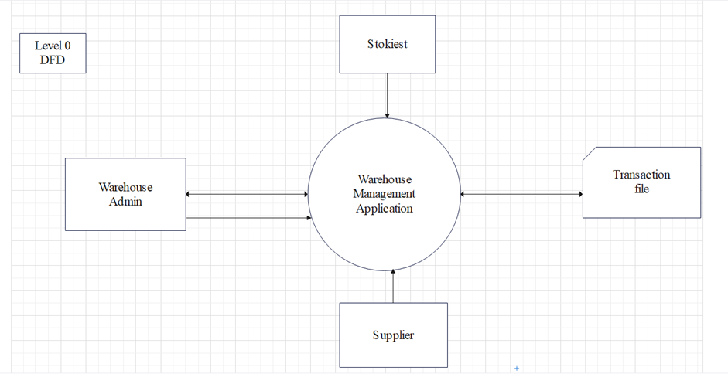

**4.2 DFD Level 1:**

STOCKIST

SUPPLIER

Supplier Details

Transaction File

Product File

Stockist Details

manage

add/edit/delete

ADMIN

add/edit/delete

select product

Place Order

Supply

update